1) What is an IDE?

- IDE stands for Integrated Development Environment

- The IDE is an editor software that provides an evironment to develop projects

by integrating to different softwares which are used as part of this project

- That means IDE provides connectivity to different sotwares from the same editor window.

- We no need to open each software in separate window those we are using in our project

- IDE provides fast development

2) What are the advantages of IDEs?

1) it gives code help (less typing, more choosing)

2) easy to copy paste and moving lines

3) auto generation of code (fields, constructors, methods, condition, loops, try, catch, finally, throws, etc...)

4) easy debugging

5) we can connect to diff sotwares from this IDE editor

6) fast development

7) time and money is saved.

3) Popular IDEs for Java application development?

1) Visual Studio Code

2) Sublime Text Editor

4) Working with visual Studio Code?

1) What is visual Studio Code?

- An visual Studio Code is an IDE software

- It is an text editor software

- It is an open source software (freely avilable to download, we can get its source code and

even we can also involve in its features development )

- It is meant for developing projects more faster with less typing.

5) How to Install a Visual Studio code.

a.https://code.visualstudio.com/download

b. click on windows button.

c. click on .exe file.

d. Go head until installation completed.

6)shortcuts

a. Increasing and Decreasing Fontsize

ctrl ++ and ctrl --

b. For indentation of oneline and multiple lines.

ctrl+] for right indentation.

ctrl+[ for left indentation.

c. For sigle line comment ctrl+/.

For multiline comment ctrl+k+u or ctrl + /

d. ctrl+x deletes whole line.

ctrl+delete , it delete the next word.

ctrl+backspace, it delete the previous word.

e. Expand selection from cursor to end of line.

shift+end.

expand selection from cursor to begining of line.

shift+home.

Expand selection from cursor to next word.

shift+ctrl+rightarrow.

Expand selection from cursor to previous word.

shift+ctrl+leftarrow.

Select whole line

ctrl+L

f. change same word at multiple locations

ctl+shift+L

g. ctl+N for creating a new file.

h. ctl+f4 for closing the active window.

i. ctl+k+f for closing the folder.

j. ctl+k , ctl+o to open a new folder.

k. move current to up and down use alt+ uparrow, alt+ downarrow.

l. create a duplicate of current line shift+alt+uparrow, shift +alt+downarrow.

m. Transform text to lowercase.

select text

i. ctrl+shift+p

ii. type 'lowercase'

iii. hit enter.

Transform text to uppercase.

i. ctrl+shift+p

ii. type 'uppercase'

iii. hit enter.

n. ctrl+shift+p to open the command palate.

7. Shortcuts to generate .html code.

a. shift+i+ enter to generate "boilar plate code".

b. opening-tag name + enter to generate to write complete element definiton.

c. Add a class to element while creating.

i. opening-tagname .classname + enter for single class.

ii. opending-tagname .classname .classname .etc + enter for multiple classes in single html element.

d. Add a Id to element while creating.

i. opening-tagnam #id+enter.

e. Add a content to element while it is being creating

opening-tagName{content}

f. Add a sibling elements

tagname1+tagname2 + ...etc.

g. Add element and child element to it.

parent element > child element

h. for grouping use '(' and ')'.

i. Multiplication

tagName* n ---> It generate n number of elements.

j. Numbering

{ content $[@startingnum]}

Example: li{item $}*3

output : <li>item 1</li>

<li>item 2</li>

<li>item 3</li>

k. adding attributes to tag.

tagname[attrname="value"]+enter

m. Form related short cut

form:

input elementname:

They display tag with avialble attributes.

n. lorem + enter . It adds the dummy text.

lorem[n]+ enter . it adds only n words of dummy text.

8. CSS shortcuts to properties definition:

a. padding Realted shortcuts:

1.p:v1unit+enter

2.p[l|r|t|b]:v1unit+enter

b. margin related shortcuts:

1. m:v1unit+enter

2. m[l|r|t|b]:v1unit+enter

c. size related shourtcuts:

1. h:v1unit+enter

2. w:v1unit+enter

d. font-related shortcuts;

1.ff:+enter -->font-family

2.ff[startingletter of familyname]+enter

EX:

ffv+enter ---> font-family:verdana;

ffa+enter ---. font-family:arial;

3.fsn+enter -->font-style:normal

fsi+enter -->font-style:italic

4.fwb+enter ---> font-weight:bold;

fwn+enter where n is weight.

Ex: fw700+enter ----> font-weight:700;

5.fz+enter -->font-size

fzunits + enter

Ex: fz200em+enter --> font-size:200em;

6.Grouping the shortcuts to create properties at time.

shorcut1+shorcut2+...etc

EX: p:20em+ffa+enter

--->

padding:20px;

font-family:arial;

9. How to create simple snippet.

It help the programmar while writing redudency code at differnt places in program.

step1:File->preferences->configure user snippets.

step2:Once you do this you will be presented with 3 main ways to create a snippets file.

2.1. A global snippets file that will work across all projects and all languages.

2.2. A project snippets file that will work only within the current project.

2.3. A language specific snippets file that will only work for one language.

step3.

Create a JSON Data.

{

"nameofSnippet":{

"scope": "language1,language2, ..etc",// This snippet will works only in these specified languages.

"prefix": "some-text", //This is the small amount of text you type that expands into the larger text.

"body":" text", // This text will be written over console, when we type "some-text + enter".

"description":"Description of snippet"

}

}

Example: create snippet for displaying "html program structure".

{

"boiler_plate":{

"scope":"html",

"prefix":"bp",

"body":[ "<hmtl>","<head>","</head>","<body>","</body>","</html>"],

"description":"It writes the html program structure"

}

}

if you type "bp+enter" on editor, you will see the basic html program structure on editor.

10. Extensions:-

Installation procedure:

----------------------

Step1: click on extension button.

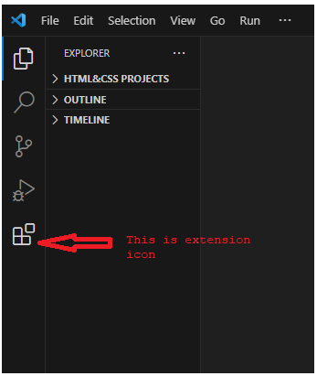

Step 2:

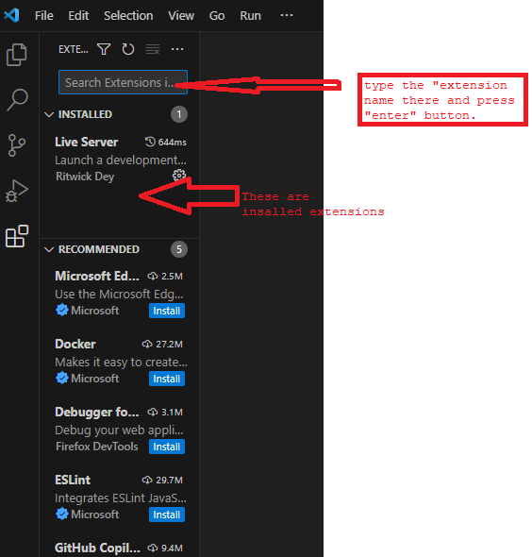

we can see the installed extension by 'ctrl+shift+x' command.

10.1. Emmit:- It is plug-in for text-editor. It improves HTML & CSS work flow.

10.2. LiveServer:- when we save changes to htmlfile in vs code IDE, Result will be reflected immediately on web page which has been opened in browser.

10.3. Auto Rename Tag:- every time you rename a tag, the complimentary opening/closing tag is renamed by itself to match the new tag name.

10.4. css peek: It helps a lot to web developer.

1. Select the id/class attribute value of element in html file.

2. Press ctrl+ click on selected id/class attribute value then ,we directly go to its style in .css file.

10.5. Relative path:- once the extension is installed, type ctrl+shift+H and type the name of the file you want to import, and hit enter. Relative path extension will now automatically add the relative path of file you requested.

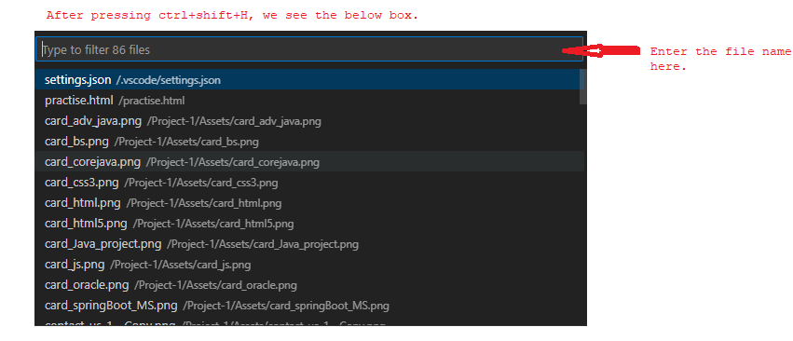

10.6. Intellicode:- it is an AI-based intellisense for java script, type script. What sets it aprt is its ability to understand the context of your code and giving those completion items suggestion at top that you are most likely to use next.

10.7.Color picker.

10.8. Colorize:- once the extension is installed and active, it automatically generates a color background for the colors defined inside your styles files(css).

Ex:-

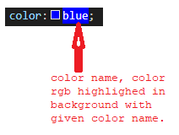s